Shafshafo’s Annual Report
2015

Introduction
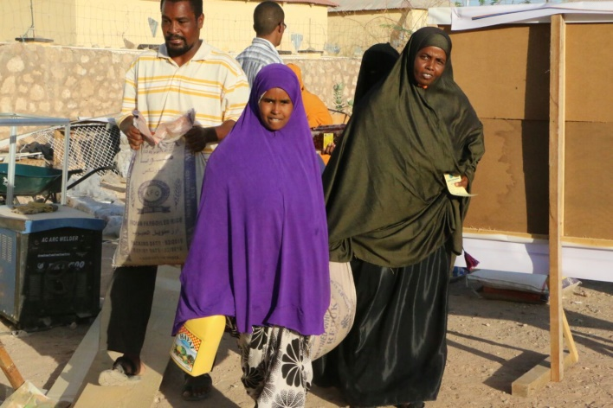
Shafshafo for Relief and Development is a non-governmental, non-profit organization which is based in Galkaio, Puntland State of Somalia. Its headquarters is in Galkaio, the capital city of Mudug region in Puntland. It was established in July 7, 2001 in Garowe, the capital city Puntland, at the height of Somali civil war. The aim of the establishment was to answer the dire need to salvage the war-displaced people, however, its activities were limited due to the fact that most of its executive committee migrated to the foreign countries. Shafshafo was reformed in 2013 and new executive committee was established.

Report on Relief Activities -2015.
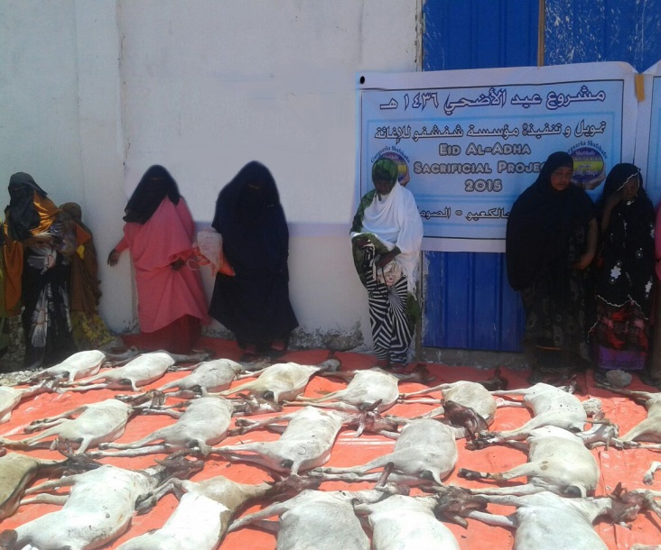
Shafshafo for Relief and Development executed a number of projects in 2015. These projects included both relief and developmental projects. The weaker sections of Galkaio and Baadweyn communities like orphans, war-widowed single mothers and the handicapped have been the focused its activities. Slaughtered animals were distributed to the most needy of these communities.
In collaboration with local relief organizations and the helping hand of business community in Galkaio, Shafshafo carried out relief activities like the delivery of food baskets and sacrificial meat for the weaker sections of both Galkaio and Baadweyn communities. The beneficiaries of Shafshafo’s activities included orphaned children, single mothers, handicapped people and nomads who lost their source of livelihood to the consecutives droughts which hit the area. These people raised animals like goats, camels, sheep and cattle.
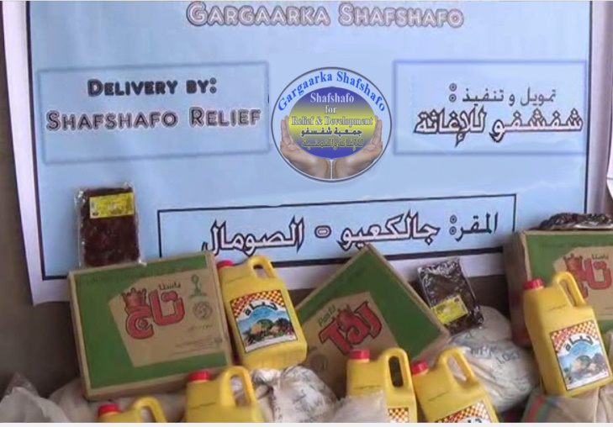
In addition to that, Shafshafo for Relief and Rehabilitation ran iftar kitchens during Ramadan for the poor in Baadweyn and delivered food baskets containing dates, cooking oil, food grains and sugar in Galkaio. Some of this food stuff was provided by the city people and distributed by Shafshafo for Relief and Rehabilitation.

Water tracking
Due to the recurrent drought spells, Shafshafo for Relief and Rehabilitation provided truckloads of water to remote areas in the countryside where animals were dying of thirst and dehydration. In cooperation with traditional community leaders in certain zones, Shafshafo donated truckloads of drinking water and even food handouts for the victims of the drought.
Partaking Flood Drainage in Galkaio

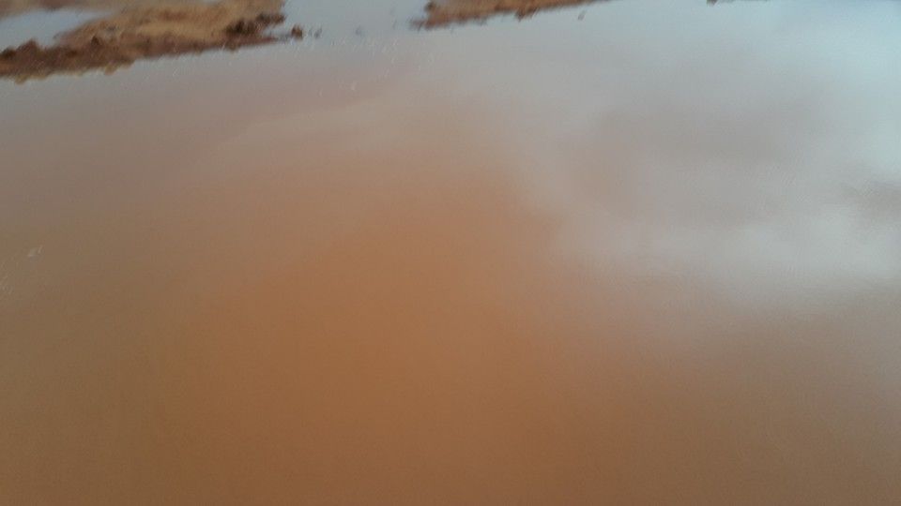
Galkaio experienced heavy downpours which cause floods in a rainy seasons in 2015. This brought life standstill in Galkaio. The Galkaio community carried out self-help scheme in order to drain out the floods from the city center. Shafshafo contributed its efforts to dig canals to drain out these floods along with city community. Shafshafo also provided implements like shovels, hoes, etc. for the excavations of the drainage systems and topping up of the water pools.

Conclusion
In conclusion, Shafshafo’s efforts to relieve the suffering of the Somali people have been well appreciated by the local community. It is aiming at extending its services to a wider community and lobby relief for the many handicapped people in the cities.
Osman Abdirahman Omar
The Secretary General of Shafshafo for Relief and Development
